**Feedback on first sprint’s outcomes**

**Question: Organization Chart**

* For the display employee’s info, pop up or onmouseover
* Satisfied with the chart? Colour?
* Satisfied with the pop up window? Size? Format? Greyed background
* Satisfied with the tooltip?
* Other requirements on UI design?

**How to deal with the situation that a supervisor leaves his job?**

* Should we keep the information for former employees? (That is, if someone want to search for a former employee, should we display the left status)
* Should we keep the unfilled position before someone replaced this position to make sure the organisational structure remains

**Constraints:**

* Will an employee have multiple jobs or positions in the sheet? No
* Will the employee have duplicated names? Yes ID
* Will the sheet have a header row? (a row indicates each columns’ meaning)
* We are forbidden to edit the sheet? Read only?
* Have we got images in the spreadsheet? Images -> do more research

**Searching and Detailed Report**

**For searching and report generation, which task shall we do first in the next sprint?**

**Searching**

**How to display the personnel’s information when a user searched a staff?** In a pop-up, in a new web page, or just show it below the chart?

**For searching, shall we implement searching by keywords or searching by filtering options, or both?** If keyword search shall be implemented, besides employee name, what other personnel information should be matched with keywords submitted by users? If filtering options shall be implemented, what shall the options be?

**How accurate?** If I search Michael, present all staffs named Michael, or no result and ask user to input the full names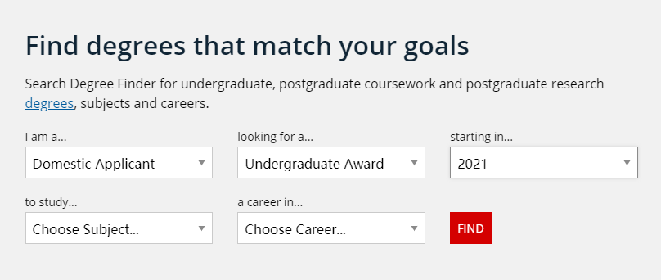

**How to display searching results?** A list of results? And users can click one to see the chart or detailed report?

**Detailed Report**

**For report generation, can you list some metrics that shall be included in the report?**

**Assignment feedback**

**Any feedback on our snapshot, what was not done well?**